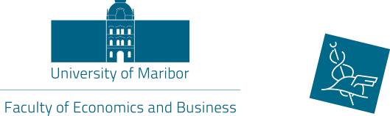
UNIVERSITY OF MARIBOR
Faculty of Economics and Busines
Razlagova 14, 2000 Maribor
Slovenia
International Relations Office

ERASMUS TRAINING in Maribor
„…let´s gain dynamic and positive experiences…“

Practical placement: Faculty of Economics and Business - International
Relations Office

Short description of main tasks:
- collaborating with foreign partners, universities and institutions;
- administrative and other tasks, considering incoming and outgoing students;
- activities in some international projects

Duration of training: 6 months

Beginning of training: 28th of February 2021 – 31th of August 2021
Conditions of payment: Erasmus or other scholarship from home institution

Requirements: - CV with photo and Motivation Letter to one of the emails
mentioned below
- well proficient in English (at least B2 level)
- well proficient in computer programmes (Word, Excell,..)
- communicative and open-minded person
- international experience
- field of study is not important

What do we offer: - all students benefits (food coupons,library);
- work in a pleasant and international environment;
- lively and young atmosphere in the city of Maribor

Contact: International Relations Office Sanja Kocijan, MSc.
Tel: +386 2 22 90 252
E-mail: sanja.kocijan@um.si or feb.international@um.si

Deadline for application : 30th of November 2020

