Prof. Olena Trokhymets

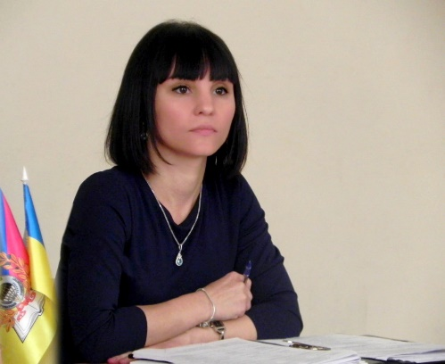
- Head of the Department of Science and International Relations, Classic Private University
- Member of Presidium of Zaporizhzhya Regional Znannia Society of Ukraine
- Professor of the Department of National Economics, Marketing and International Economic Relations of the Institute of Economics and Law of the Classic Private University
- Professor of the Department of Theory and Practice of Translation of the Classic Private University (in addition to primary employment)

Professional Summary, Skills: I possess good administrative, organizational, and analytic and communication skills; experienced in monitoring situations; able to work both in a team and independently; able to handle multitask situations and priorities; possess the experience in managing and coordination of personnel; experienced in organizing and conducting activities; strong disciplined; responsible; straightforward. Open to new “horizons” and learn something new.
Courses taught: International Economics, International Strategies for Economic Development, Marketing, International Marketing; Marketing of Tourism and Hotel and Restaurant Business; Business English, Theory and Practice of Translation, Busines Etiquette and Protocol.

